 The update of Airlab bootloader is non-mandatory, so we hope you can do the following manually。

        Step 1 .   Use ISP Tool to select the repair_bootloader_airlab.hex in the attachment. Use RS485 port ,Select the corresponding ID   and baudrate. After this step is updated, the device's screen will always be in a double-flash state.

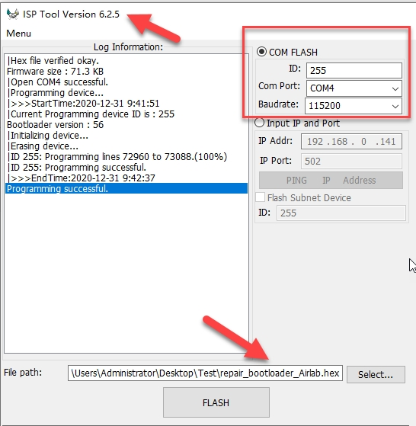

       Step 2 .  Select the latest version of Airlab firmware, version 11.4, as attached

                     Also use RS485 to update the firmware airquality_rev11_4.hex

                     When the update is complete, the device is in normal working mode.

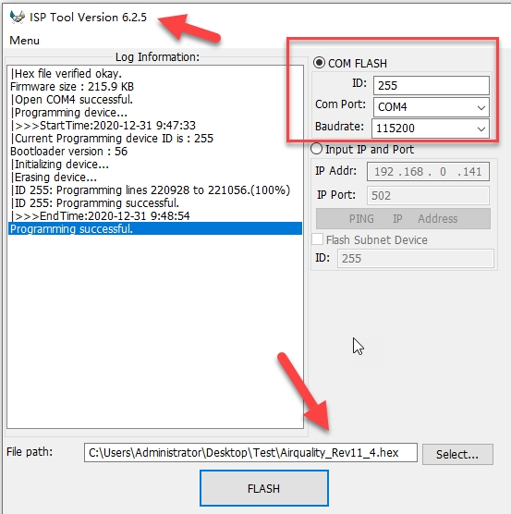

      Step 3 .  Using the T3000 software, you can know the device's Wifi IP Address

                    Then we can use this IP address to update the required firmware

